**PSL Management System**

**D.B.M.S Project**



**Project By:**

* Bilal Zubairi (CS-21091)
* Muhammad Faizan Khan (CS-21070)
* Salman (CS-21099)

Course Name: Database Management System (D.B.M.S)

Course Code: CS-222

Batch: 2021

Date of Submission:

Department: Computer and Information Systems Engineering

**C E R T I F I C A T E**

Certified that following students have successfully completed the DBMS project titled“PSL Management System” assigned as a mandatory requirement for qualifying the practical examination of the course.

Bilal Zubairi (CS-21091) ___________________

Muhammad Faizan Khan (CS-21070) __________________

Salman (CS-21099) ___________________

________________

Name & Signature

**Project Examiner**

**Abstract**

The project will require developing a database to store data about teams, players, match timings and names of different grounds where two different teams will play against each other. The categorization of different entities like pitch report, commentary, umpiring will help in finely managing the different operations of cricket ground. The next essential feature is to construct an application for managing different operations including scheduling of matches, standing of teams, stats of different players and seating arrangement of crowd. Umpiring, scoreboard of batting, bowling and drafting of players. Moreover, it will also provide quick search facility to retrieve player information, team information, and match timings.

**Table of Contents**

|  |  |  |
| --- | --- | --- |
| **S. No** | **Topic** | **Page No.** |
| 1 | Introduction | 1 |
| 2 | Requirement Formulation and Analysis | 1 |
| 3 | Entity Relationship Model | 3 |
| 4 | Tables | 4 |
| 5 | Normalization | 4 |
| 6 | D.D.L Statements | 6 |
| 7 | Implementation of front-end and back-end | 9 |
| 8 | Security of Database | 11 |
| 9 | Individual Contributions | 12 |

# Introduction:

This project is basically a website which is developed to show complete statistics of Pakistan Super League (P.S.L). We went through many websites searching for stats of P.S.L season 6 but there were none which could gave the complete stats even the official website of Pakistan Cricket Board (P.C.B) was lacking the information. Therefore, we gathered data from different websites and also referred to the highlights that were uploaded on YouTube and at the end we collectively present the complete statistics within our website.

# REQUIREMENT FORMULATION AND ANALYSIS (DATABASE DESIGNING):

This application is related to the database of different teams,players information of HBL PSL 6th edition.This database will give be applicable in searching player information and inserting their stats and category.In the database each player will be having player id and player name and the data of different teams played in this mega event for example each player will be playing for a particular team and the team will be having a team id and team name and the database will also contain the information about the match schedule because every team will play a match with their opponents so each match have unique attributes like match id and date and the match toss will be decided by umpires so every umpires will have an umpire id and umpire name. This will facilitate in searching each data of every player in read only mode for the user. Only the database administrator will have the access to edit the information about players,match schedules or managing staff of the ground we can further also add more previous HBL PSL edition database about cricketers and match schedules in future for the advancement of the database and applications.

Moreover, each player information will be obtained by just searching player name all their stats will be displayed. Database also maintains the category of each of the team players and retrieving umpires’ information of the matches and team standings. Every match will be played in the stadium so the database will also maintain the information regarding in which stadium the match is played. Every stadium will have a stadium Id and stadium name. In the database each stadium information will also contain the pitch report of the stadium and also stores the location of the stadium and its capacity. scheduling of matches, standing of teams, stats of different players and seating arrangement of crowd. Umpiring, scoreboard of batting and bowling and drafting of players. Moreover, it will also provide quick search facility to retrieve player information, team information, and match timings.

# Entity Relationship Model:

Stadium

Is played in

Umpire

Match

Has a

Team

PLAYER

Decided by

Plays for

# Tables:

1)Team(ID,Name,Location,Owner,coach,captain,performance)

2)Players(ID,Name,DOB,Role,Style,Height,team_id,Nationality,Performance,category)

3)stadium(st_ID,st_Name,st_pitch_report,st_location,st_capacity)

4)Match(ID,Matchtimings,toss,commentator,Match_date,umpire_id,score,stats,st_id,match_between,match_number)

5)Umpire(umpire_id,umpire_name,nationality,experience)

# Normalization:

**1NF**

Player­_ID,Team_ID,Match_ID,Stadium­_ID,Umpire_ID🡪player_Name,height,Role,Style,Nationality_P,category,D.O.B_P,Age_P,Performance_P,team_Name,owner,coach,team_loc,captain,performance-t,Match_date,Match_Time,teamId,Team-2,commentator,toss-winner,choose_to target,stats,stadium_name,stadium_location,Pitch_Report,stadium_capacity,Umpire_Name,D.O.B-u,Age-u,years of experience,Nationality-u

Player_ID🡪player_name, height, role, style, Nationality-P, category, D.O.B, performance

Team_ID🡪team_name,owner,coach,team-loc,captain,performance

Match_ID🡪Match_Date,Match_Time,team 1,team 2,commentator,toss-winner

UmpireID🡪Umpire_Name,D.O.B-U,Age-U,years of experience

**2NF**

FD1:Player­_ID,Team_ID,Match_ID,Stadium­_ID,Umpire_ID🡪player_Name,height,Role,Style,Nationality_P,category,D.O.B_P,Age_P,Performance_P,team_Name,owner,coach,team_loc,captain,performance-t,Match_date,Match_Time,teamId,Team-2,commentator,toss-winner,choose_to target,stats,stadium_name,stadium_location,Pitch_Report,stadium_capacity,Umpire_Name,D.O.B-u,Age-u,years of experience,Nationality-u

FD2:Player_ID🡪player_name,heightrole,style,Nationality-P,category,D.O.B-p,Age-p,performance-p

FD3:Team_ID🡪team_name,owner,coach,team-loc,captain,performance-t

FD4:Match_ID🡪Match_Date,Match_Time,team 1,team 2,commentator,toss-winner

FD5:Umpire_ID🡪Umpire_Name,D.O.B-U,Age-U,years of experience

**3NF**

Player_ID🡪Performance_P,Age_P,D.O.B_P,category,nationality_P,style,role,height,player_Name

Team_ID🡪performance_t,captain,team_loc,coach,owner,team_Name

Match_ID🡪toss_winner,commentator,Team_2,team_1,Match_Time,Match_Date

Umpire_ID🡪nationality_u,yearsofexperience,Age_u,D.O.B_u,Umpire_Name

# D.D.L Statements:

CREATE TABLE psl.stadium(

Stadium_id INT NOT NULL UNSIGNED AUTO_INCREMENT,

Stadium_Name VARCHAR(100) NOT NULL,

Location VARCHAR(100) NOT NULL,

Pitch_condition VARCHAR(100) NOT NULL,

Capacity INT UNSIGNED NOT NULL,

PRIMARY KEY(stadium_id));

CREATE TABLE psl.team (

Team_id INT NOT NULL UNSIGNED AUTO_INCREMENT,

Team_Name VARCHAR(150) NOT NULL,

Location VARCHAR(100) NOT NULL,

Owner VARCHAR(100) NOT NULL,

Coach VARCHAR(100) NOT NULL,

Captain VARCHAR(100) NOT NULL,

PRIMARY KEY(team_id));

CREATE TABLE psl.umpire(

Umpire_ID INT NOT NULL UNSIGNED AUTO_INCREMENT,

D.O.B DATE NOT NULL,

Umpire_name VARCHAR(150) NOT NULL,

Nationality VARCHAR(150) NOT NULL,

Years_of_experience INT NOT NULL,

PRIMARY KEY(Umpire_id));

CREATE TABLES psl.players(

Player_id INT NOT NULL UNSIGNED AUTO_INCREMENT,

Player_name VARCHAR(250) NOT NULL,

D.O.B DATE NOT NULL,

Height INT NOT NULL UNSIGNED,

Role VARCHAR(50) NOT NULL,

Style VARCHAR(50) NOT NULL,

Nationality VARCHAR(80) NOT NULL,

Performance VARCHAR(80) NOT NULL,

Team_id INT NOT NULL,

PRIMARY KEY(player_id));

CREATE TABLE psl.match(

Match_id INT NOT NULL UNSIGNED AUTO_INCREMENT,

Match_date DATE NOT NULL,

Match_time TIME NOT NULL,

Team_1_id INT NOT NULL,

Team_2_id INT NOT NULL,

Toss_winner INT NOT NULL,

Choose_to VARCHAR(5) NOT NULL,

Score INT NOT NULL,

Stats VARCHAR(255) NOT NULL,

Match_Winner INT NOT NULL,

Commentator VARCHAR(100) NOT NULL,

Umpire_No INT NOT NULL,

Umpire_id INT NOT NULL,

Stadium_id INT NOT NULL,

PRIMARY KEY(match_Id));

# Implementation of Front-End and Back-End:

For the front-end we used HTML, CSS and additional CSS frameworks like Bootstrap and animate CSS.we also implemented Font Awesome Library of css and Also used carousel Slider in order to display a eye-catching frontend.We Also Implemented Javascript query to save the table forms

For back-end we have use PHP which has MySqli extension that fetches and retrieves the data

We also implemented All the files in our project using Php

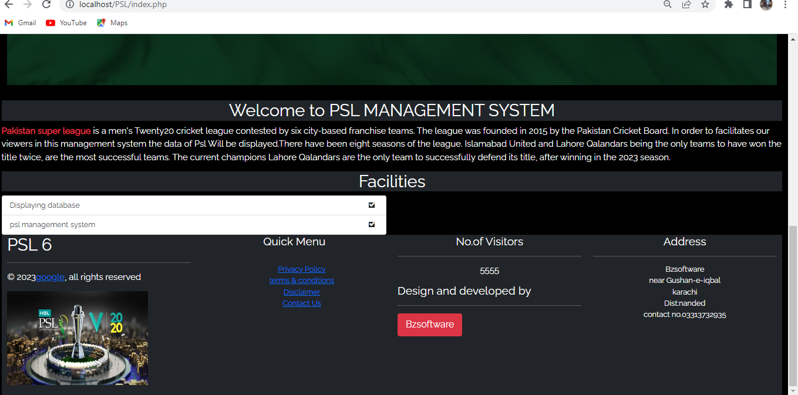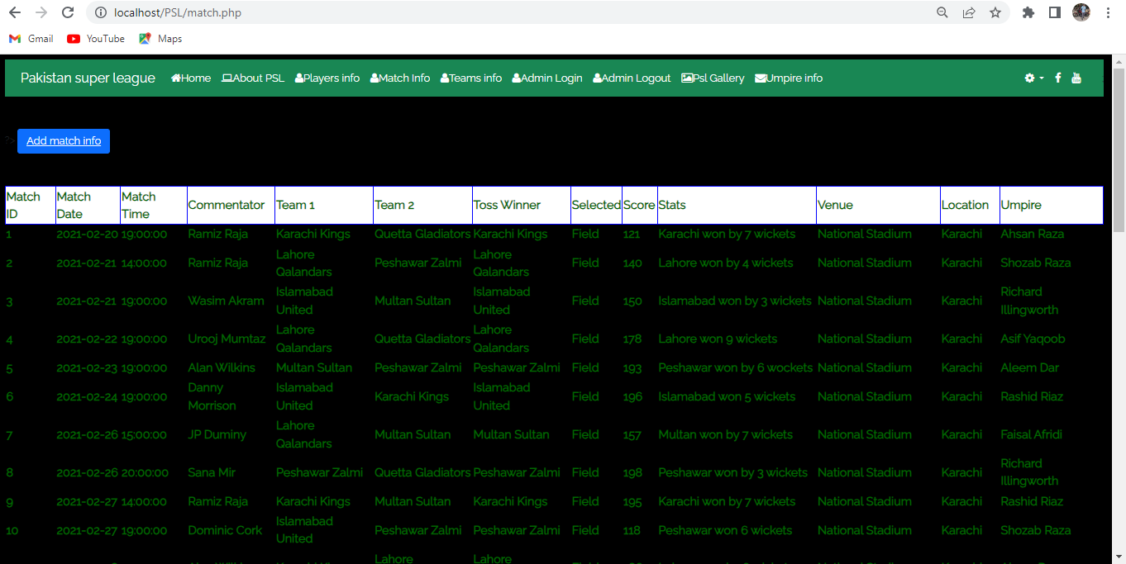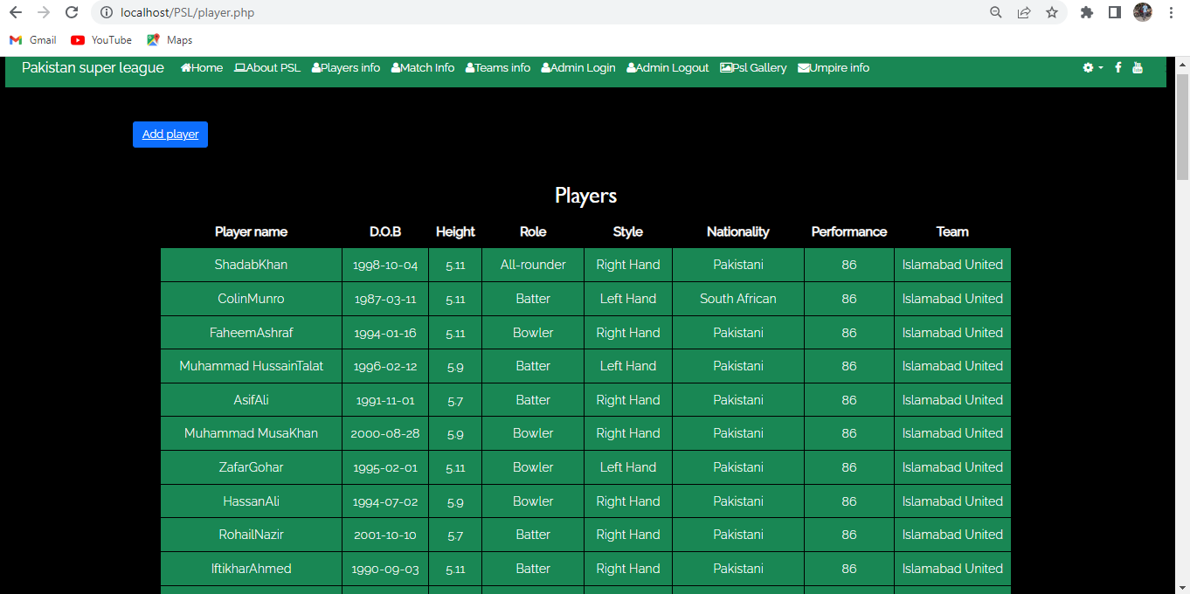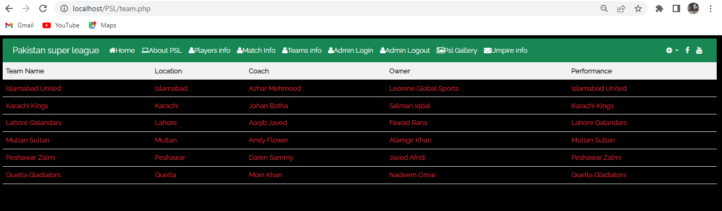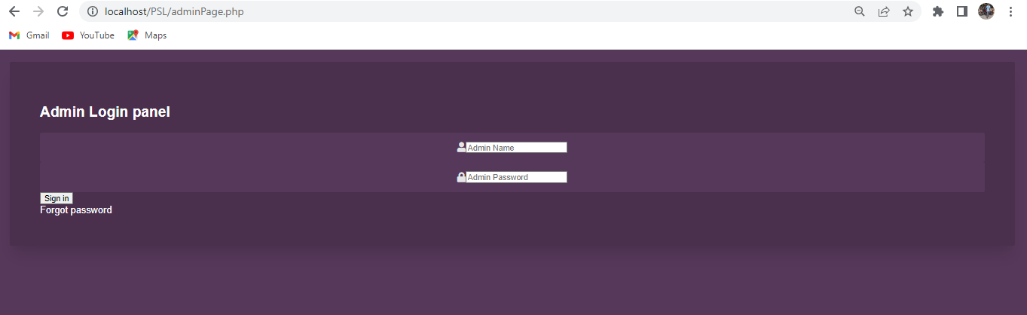

# Security of Database:

We have used the mysqli extension of PHP which allows integrated security and prevents the database from SQL injection attacks. we have avoided the use of default port for integrating our database.

# Github Repository:

https://github.com/FaizanK116/DBMS-Project

# Individual Contributions:

* Salman made the Entity Relationship Model and normalized the tables.
* Faizan went through different websites to gather the information and collectively created the data set and schema.
* Bilal developed the front-end and back-end of the website using HTML, CSS, and PHP additional frameworks like bootstrap and animate CSS were also used.